Minimax and Alpha-Beta Pruning

Question 1: Minimax Manual Trace
Problem
Trace the supplied tree by hand using Minimax.
How to solve
The tree has 6 scores [3, 5, 2, 9, 0, 7], padded with two 0 leaves to get 8 leaves (depth 3). The root is MAX, the next level is MIN, and the level above the leaves is MAX. First, each MAX node selects the larger value from its children. Then each MIN node selects the smaller value. Finally, the root MAX selects the largest value from its children.
Output / Trace
Level | Node | Children | Value
Depth 2 (MAX) | A1 | 3, 5 | 5
Depth 2 (MAX) | A2 | 2, 9 | 9
Depth 2 (MAX) | A3 | 0, 7 | 7
Depth 2 (MAX) | A4 | 0, 0 | 0
Depth 1 (MIN) | B1 | 5, 9 | 5
Depth 1 (MIN) | B2 | 7, 0 | 0
Root (MAX) | Root | 5, 0 | 5

Result: the optimal value is 5.
Question 2: Leaf-Evaluation Counter
Problem
Add a leaf-evaluation counter to both algorithms.
How to solve
I added a global variable leaf_count to both functions. It increases by 1 each time the base case (a leaf) is reached. Both algorithms were run on the same tree [3, 5, 2, 9, 3, 5, 2, 9]. Minimax checks every leaf, while Alpha-Beta can skip some leaves after pruning.
Results
Algorithm | Root value | Leaves evaluated
Minimax | 5 | 8
Alpha-Beta | 5 | 6

Alpha-beta gives the same value but skips 2 leaves. The output of my code is shown below:
Output
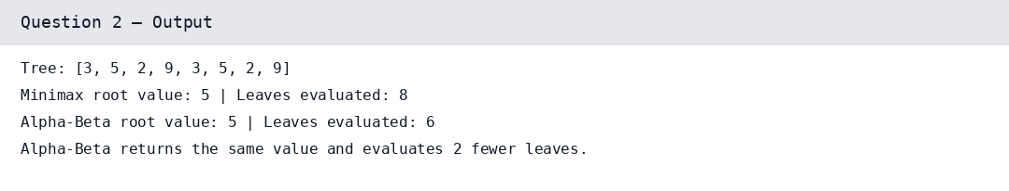
Question 3: Branch Ordering and Pruning
Problem
Reorder branches and observe how pruning changes while the Minimax value remains the same.
How to solve
Alpha-Beta pruning depends on the order in which branches are checked. A good order can find a strong move early and prune more branches. A poor order can delay pruning. The Minimax value stays the same for every ordering.
Results
Ordering | Leaf order | Value | Leaves evaluated
Original | 3, 5, 2, 9, 3, 5, 2, 9 | 5 | 6
Best-case | 3, 5, 9, 2, 3, 5, 2, 9 | 5 | 5
Worst-case | 9, 2, 5, 3, 9, 2, 5, 3 | 5 | 8

When the strong move is checked first (best-case), more branches are cut off and only 5 leaves are evaluated. In the worst-case ordering nothing is pruned, so Alpha-Beta does the same work as Minimax (8 leaves).
The output of my code is shown below:
Output
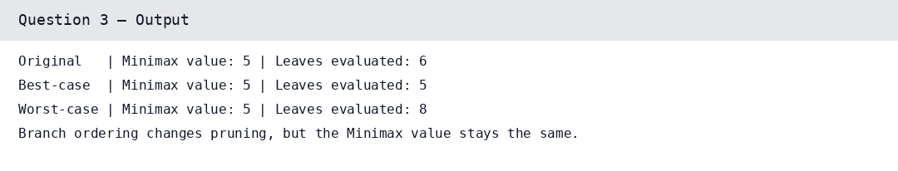
Edge case: with the worst ordering, Alpha-Beta saves nothing. Conclusion: move ordering changes how much is pruned, but never the Minimax value.

